**InControl – Configuration Manual**

|  |  |  |
| --- | --- | --- |
| Versie | Reden | Uitvoerder |
| 1.0 | First issue | KHE |

|  |
| --- |
| Inhoudstabel |

1 Introduction 3

2 General settings 4

2.1 Default acknowledge time 4

2.2 Default timeout Time 4

2.3 Reasons 4

3 Module 5

3.1.1 OPC License 5

3.1.2 Module list 5

4 Email 6

5 Roles 7

6 Users 8

7 Groups 9

8 Workflow 10

# Introduction

This document describes the necessary steps to successfully complete an InControl configuration setup. This document can be used together with the customer to go over the basic configuration settings and features to fully configure and use InControl.

# General settings

## Default acknowledge time

This setting will be used to define the minimum time a bypass can remain active

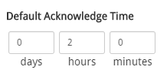

## Default timeout Time

When working with approval and you require a reminder time if the bypass is not approved resend an email based on this time setting.

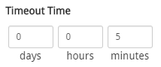

## Reasons

When requesting or acknowledging a bypass. Default reasons can be configured.

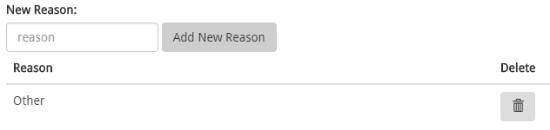

By default, “Other” is configured. This reason will give an addition field were the user can give in additional unrestricted reasoning. For other used reasons please add them to the list. Some suggestions:

* Maintenance
* Shutdown
* Startup
* I/O problems
* Wrong bypass

By using these default reasons analyses will be more easily and you can optimize your process

# Module

### OPC License

Setup your maximum amount of used OPC tags. This can be useful if you would like to limit the license cost or load on your DCS system. Take in consideration that a limit to low can create latency in the use of InControl. Recommended practice is to take the number of used module tags

### Module list

Load in your module list through a .csv file or add one manually.

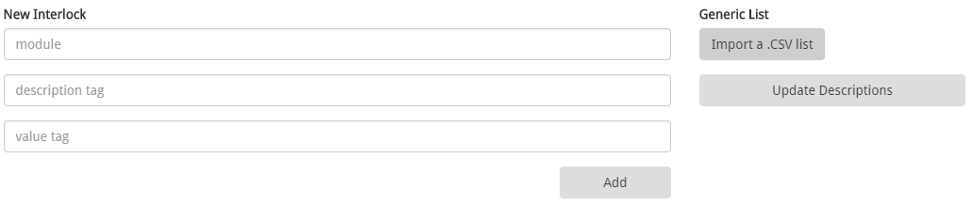

The .csv (comma separated) file has the following format and can be easily generated by a spreadsheet application.

|  |  |  |  |  |
| --- | --- | --- | --- | --- |
| Module | DescriptionTag | Description-Extension | ValueTag | Value-Extension |
| Module name tag to be monitored | The parameter that reference the description of the bypass. Usually the information presented to the operator | The extension attribute of this parameter | The parameter that reference the actual value of the bypass. Usually this is a boolean presented to the operator | The extension attribute of this parameter |

# Email

For creating and sending emails you can configure the default SMTP server settings:

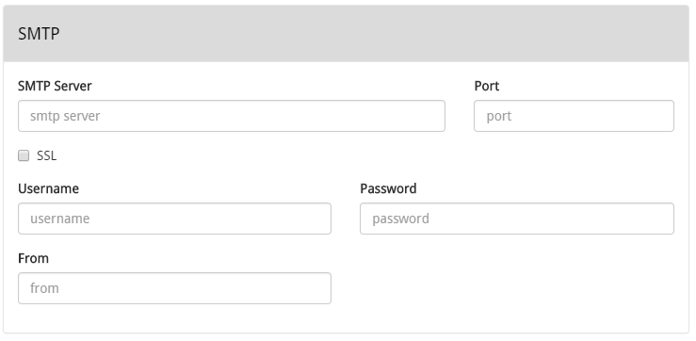

If you don’t use the email functionality you will not be able to send email reminders, notifications for approval and user information when creating account.

*There is an additional feature to send a test email.*

# Roles

InControl by default support 5 roles. You can use and configure these roles as you require. All the roles can be configured with specific rights based on your site needs. A default configuration has been selected. Please go over these settings to make sure it meets your site needs

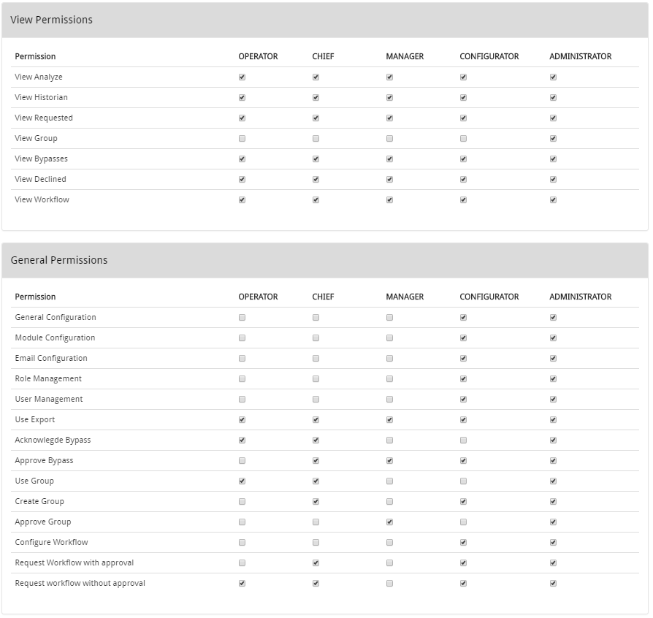

**Operator**: Usually used only for visualization and requesting bypasses

**Chief**: Usually used for low level approval, analytics and creating groups

**Manager**: Usually used for high level approvals of bypasses and groups

**Configurator**: Somebody with configuration rights without being admin (site specific)

**Administrator**: Full rights control

# Users

Add users ass required in combination with the correct role.

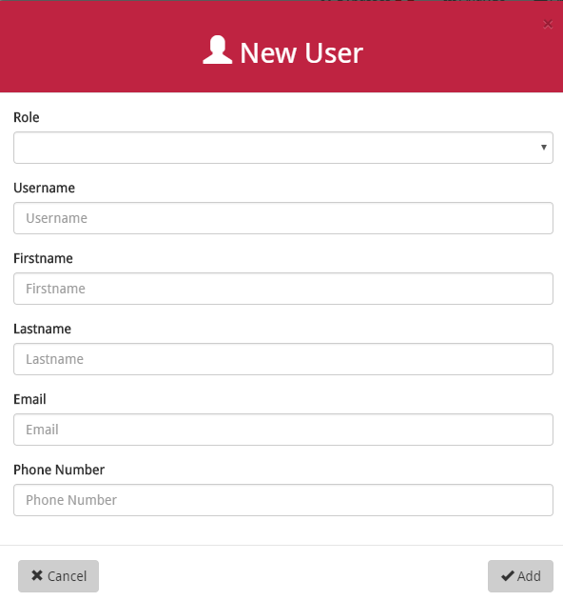

By default, after creating a user an email will be send to the user containing their account login information. When email is not configured the password will be “*default*”. After logging in with your account the user can change this password by clicking on their account name.

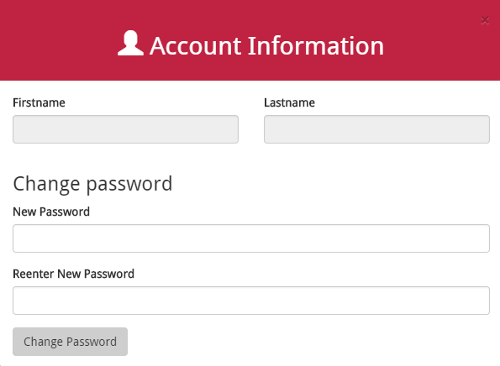

# Groups

Make different types of groups to request bypasses that can be grouped by one request

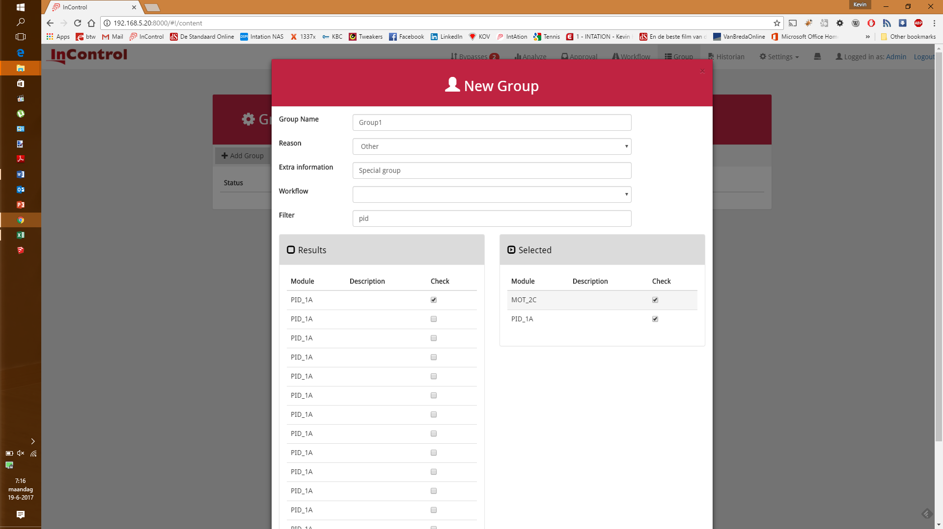

# Workflow

Name and configure the 2 available workflows as required.

